 | Namal University Mianwali  Department of Computer Science

CSC-140 Digital Logic Design Time: 3 hours. Marks: /10
Instructor: M. Ramzan Shahid Khan Dated: 19/05/2025
Student Name: Najeeba Registration #:NUM-BSCS-2024-61
Student Name: Najia Nayab Registration #: NUM-BSCS-2024-62
Lab #: 12

- Equipment/component used: -
- Breadboard
- Connecting wires
- LED indicators
- NAND gate
- Logic probe (BIG)
- Logic toggle
- Explanation of equipment: -
- Logic probe (BIG): -
A logic probe is a tool used in electronics to test and analyze digital circuits. It helps determine whether a signal is high (1), low (0).
- Logic toggle: -
A logic toggle switches between two states typically ON (1), OFF (0) in digital circuits. A toggle flips its output state whenever it receives a triggering signal.
- NAND: -
A type of logic gate used in digital electronics. A NAND gate produces an output that is false when all its inputs are true otherwise it produces true.
- Safety measures: -
  - Before soldering the Power button of Analogue and Digital Training system is off.
  - Set the voltage to 5V.
  - Before touching the wires, make sure that the power button of Analogue and Digital Training system is off.
Task 1: SR Latch using NAND Gates
- Procedure: -
- Connect the first input S to one of NAND gate.
- Connect the second input R to another NAND gate.
- Connect the output of first NAND gate to one pin of second NAND gate.
- Connect the output of second NAND gate to one pin of first NAND gate.
- The output of the first NAND gate will be Q.
- The output of the second NAND gate will be Q’.
- Images: -
- For proteus: -
- When s=0 and R=1 the Q will be 1 and Q’ will be 0.
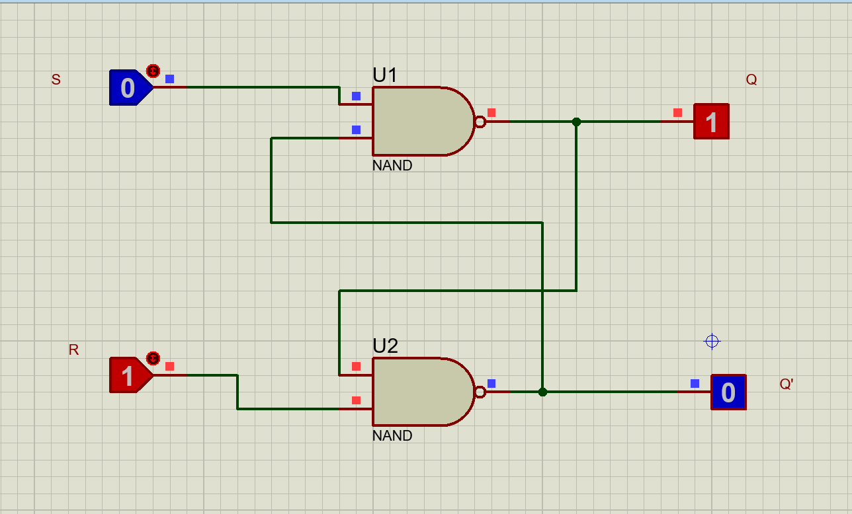

- When S=0 and R=0 then Q=1 and Q’=1
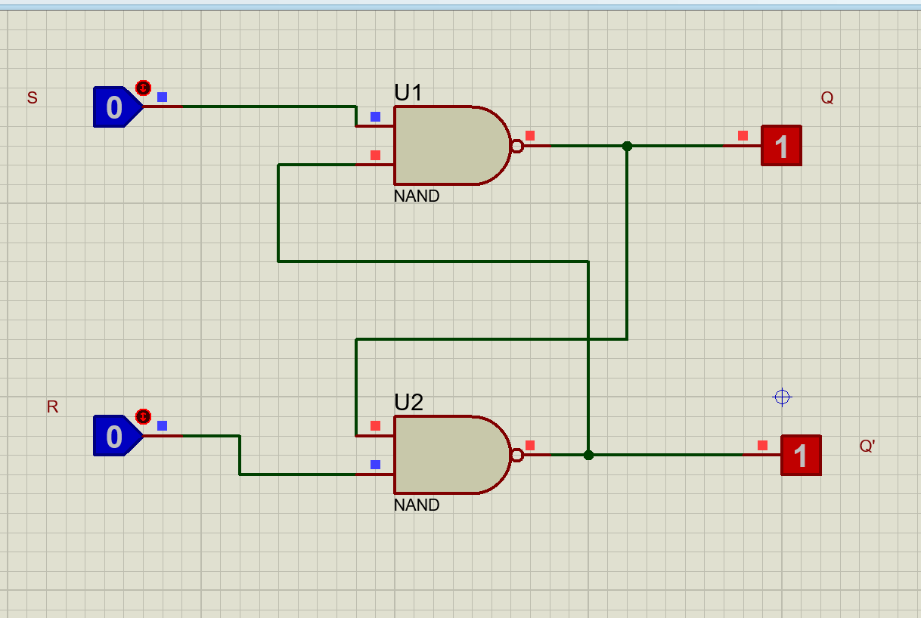
- When S=1 and R=0 then Q=0 and Q’=1
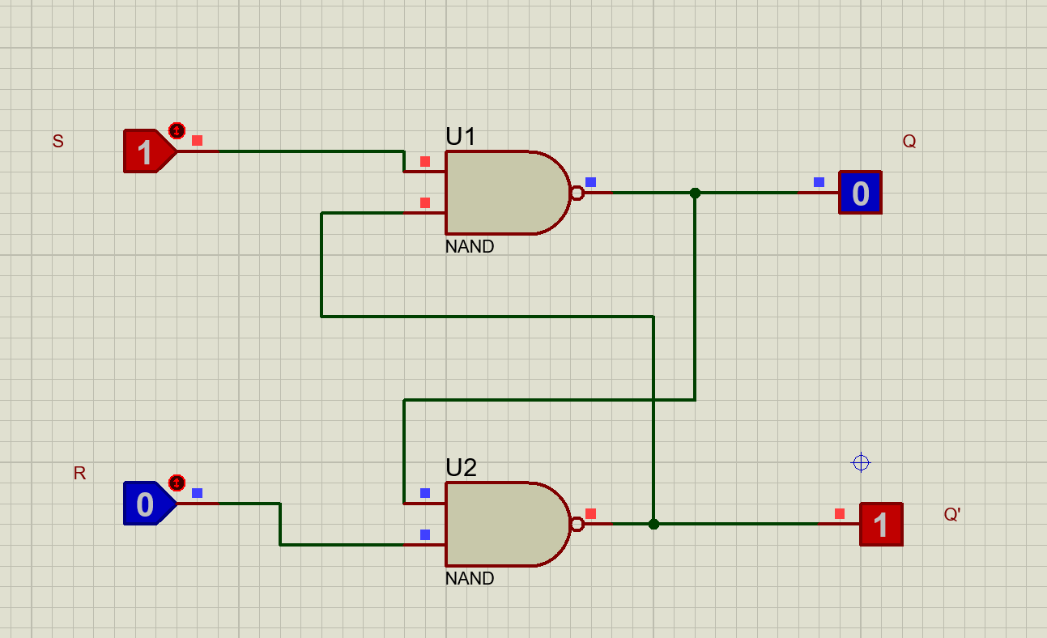

For Breadboard:
Image 1:
- When S=0 , R=1 then Q=1 and Q’=0
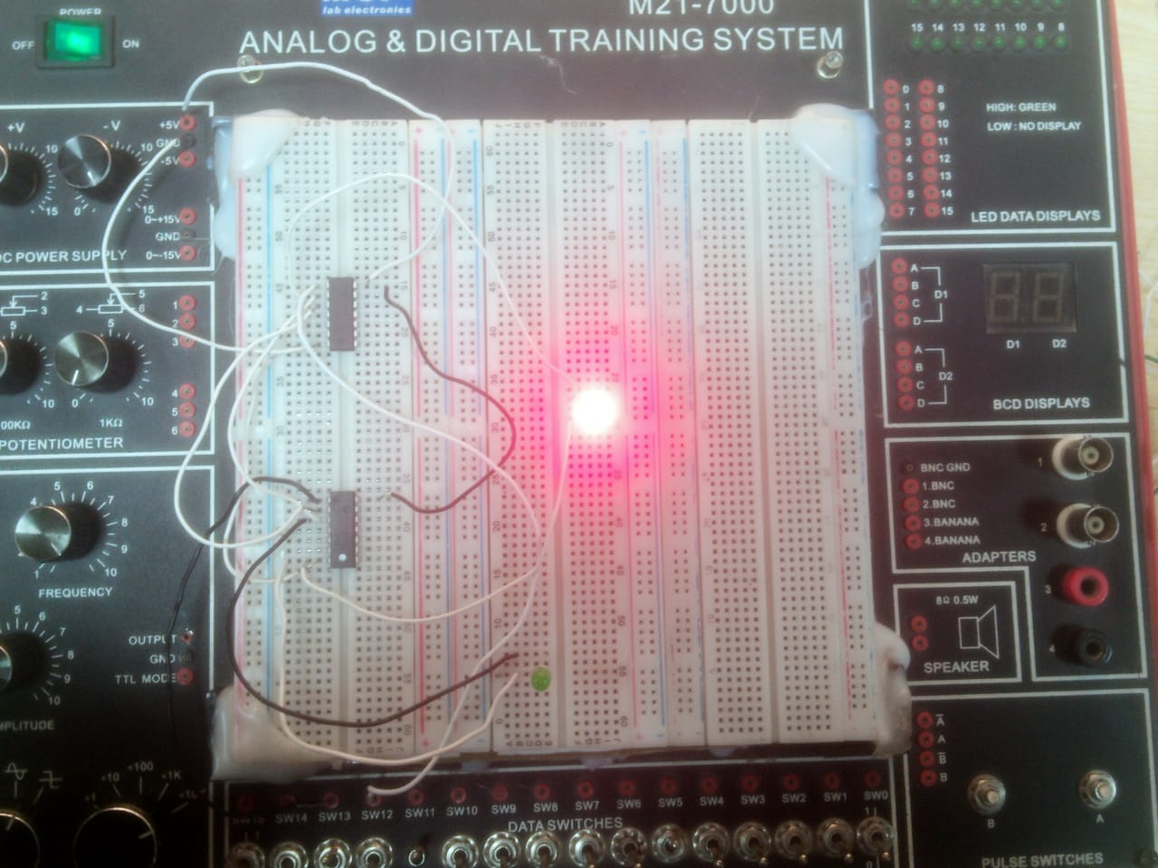
Image 2:
- When S=0 , R=1 then Q=0 and Q’=0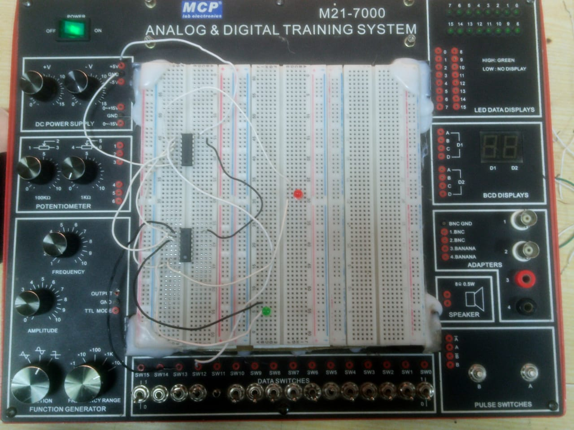

Task 2: SR Latch using NOR Gates

- Procedure (Bread Board):
- Place the 7402 IC on the breadboard.
- Connect the power supply (5V) and ground to the IC.
- Connect the first input (S) to one of the NOR gates.
- Connect the second input (R) to another NOR gate.
- Connect the output of the first NOR gate to one input of the second NOR gate.
- Connect the output of the second NOR gate to one input of the first NOR gate.
- The output of the first NOR gate will be Q.
- The output of the second NOR gate will be Q'.
- Use the logic probe to test the outputs.
- Use the logic toggle to switch between the states of S and R.

- Procedure (Proteus):
• Use the 7402 IC (NOR gates) to build the SR latch.
• Connect Vcc and GND pins properly to the power supply.
• Attach two switches for inputs S and R.
• Connect LEDs to the outputs to display the states of Q and Q'.

- Image (Bread Board):
Image 1:

- When S=1, R=0 then Q=0and Q’=1

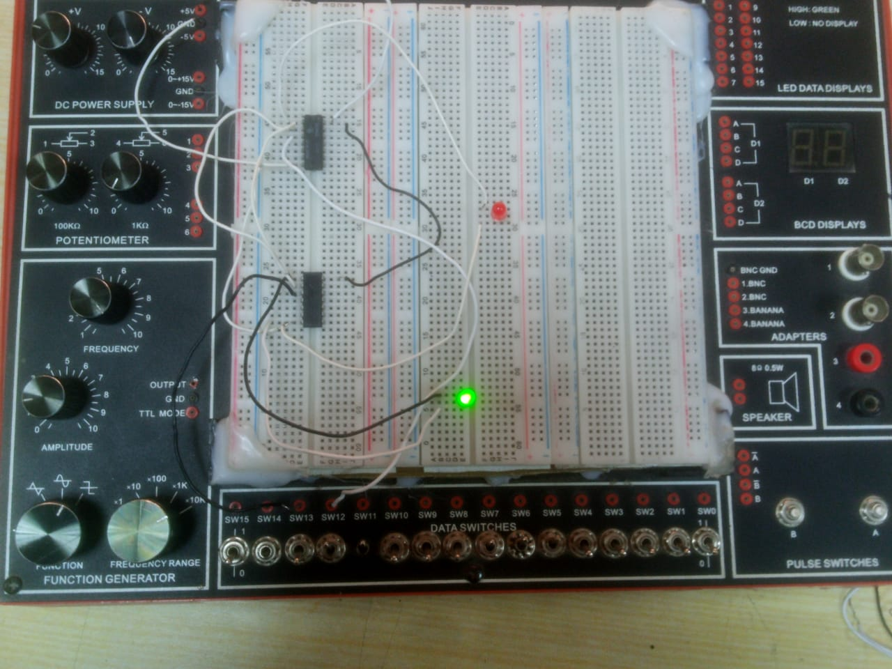
Image 2:
- When S=0, R=1 then Q=1 and Q’=0
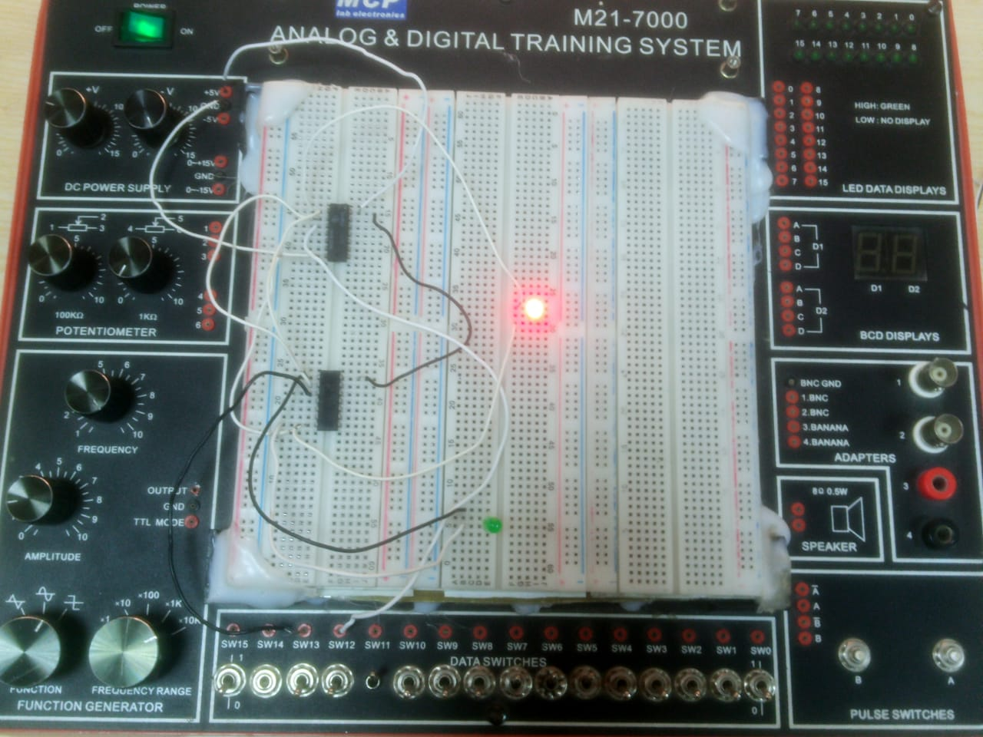
- Images (proteus):

Image 1:

- When S=1, R=1 then Q=0and Q’=0
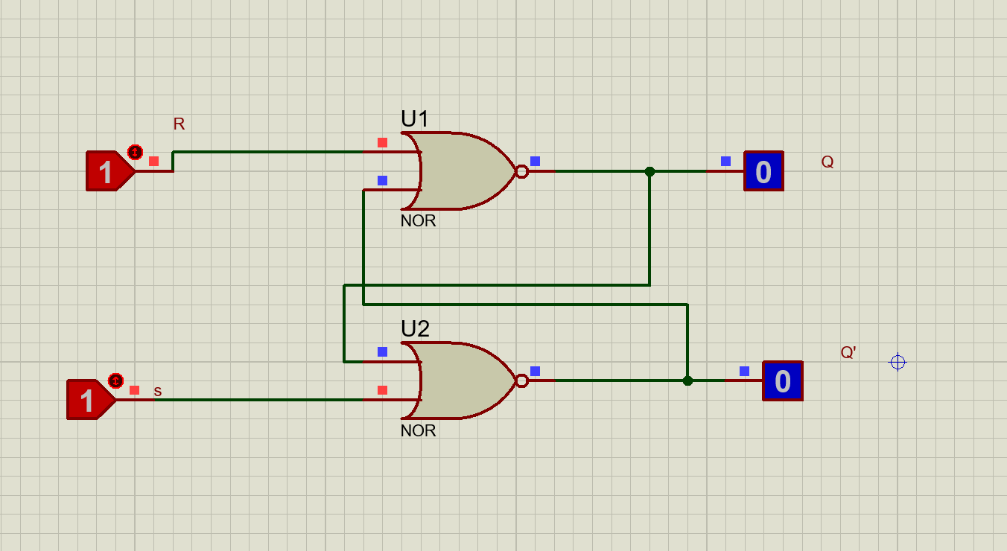
Image 2:
- When S=0, R=0 then Q=0and Q’=1

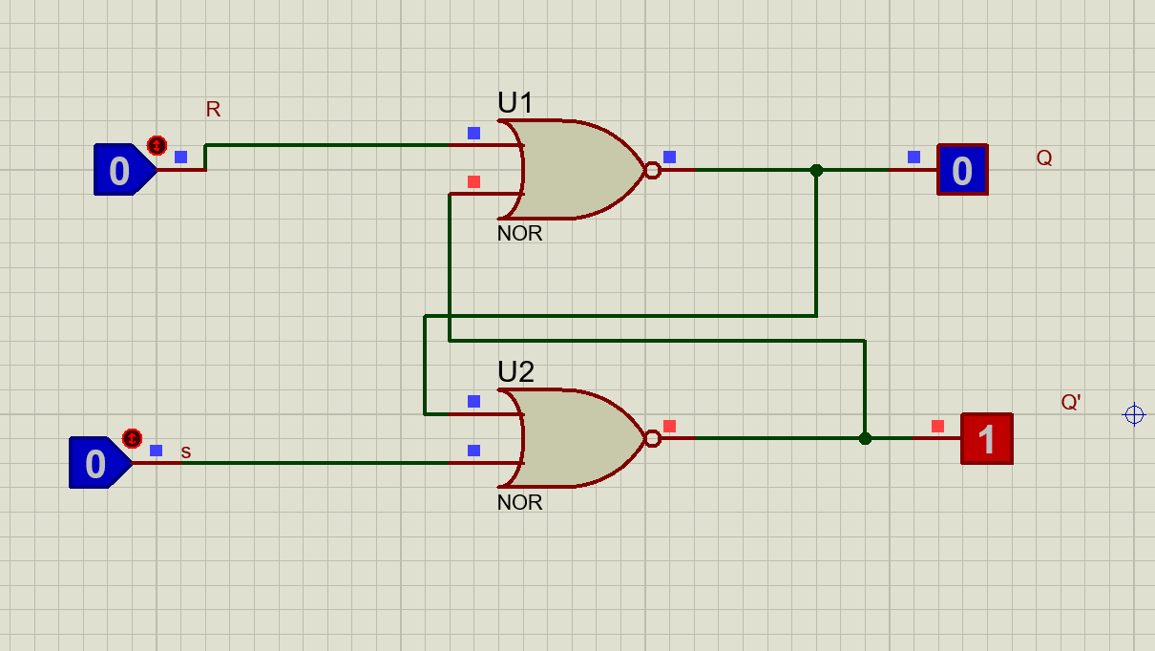
Image 3:
- When S=1, R=0 then Q=0and Q’=1
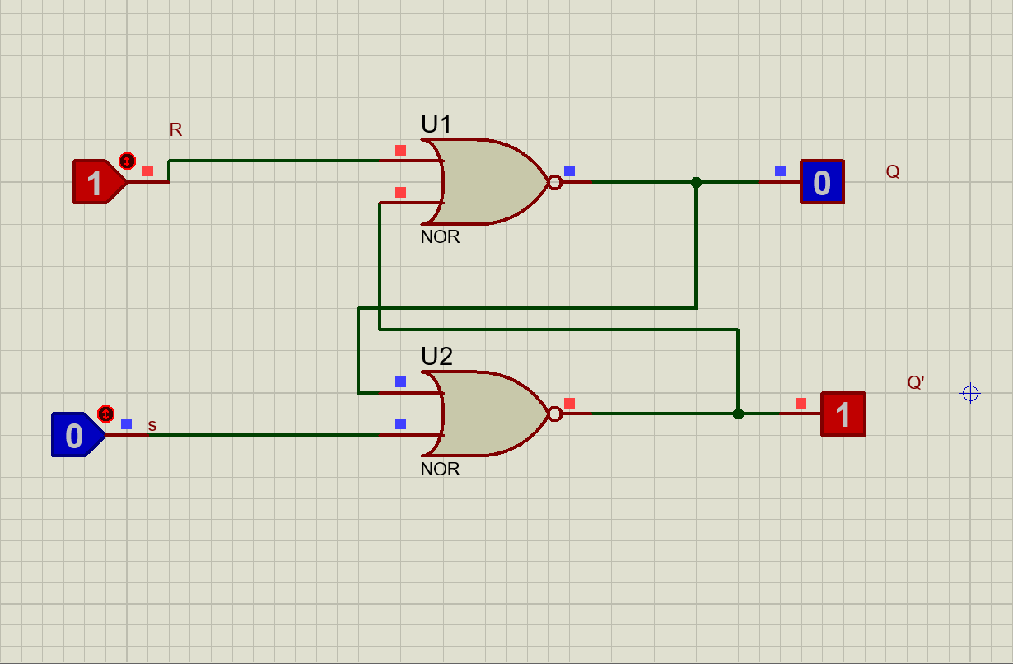
Task 3: D Latch
- Procedure (Bread Board):

- Place the 7402 IC on the breadboard.
- Connect the power supply (5V) and ground to the IC.
- Connect the first input (S) to one of the NOR gates.
- Connect the second input (R) to another NOR gate.
- Connect the output of the first NOR gate to one input of the second NOR gate.
- Connect the output of the second NOR gate to one input of the first NOR gate.
  - The output of the first NOR gate will be Q.
  - The output of the second NOR gate will be Q'.
- Use the logic probe to test the outputs.
- Use the logic toggle to switch between the states of S and R.
Procedure (Proteus):
- Use the 7400 IC (NAND gates) and 7404 IC (Inverter gates) to build the D Latch.
- Connect Vcc and GND pins properly to the power supply.
- Attach a switch for the data input (D).
- Attach another switch for the enable input (E).
- Connect LEDs to the outputs to display the states of Q and Q'.

- Images (Bread Board):
Image 1:
- When D=1, E=1 then Q=1and Q’=0
- 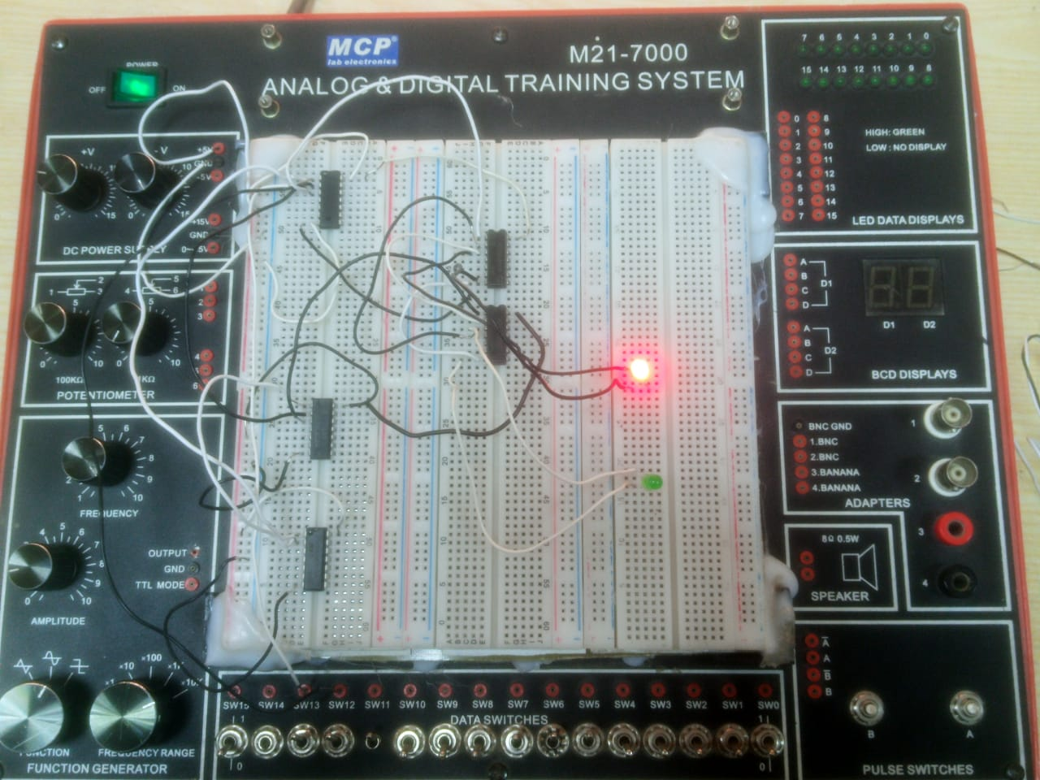
Image 2:

- When D=0, E=1 then Q=0 and Q’=1

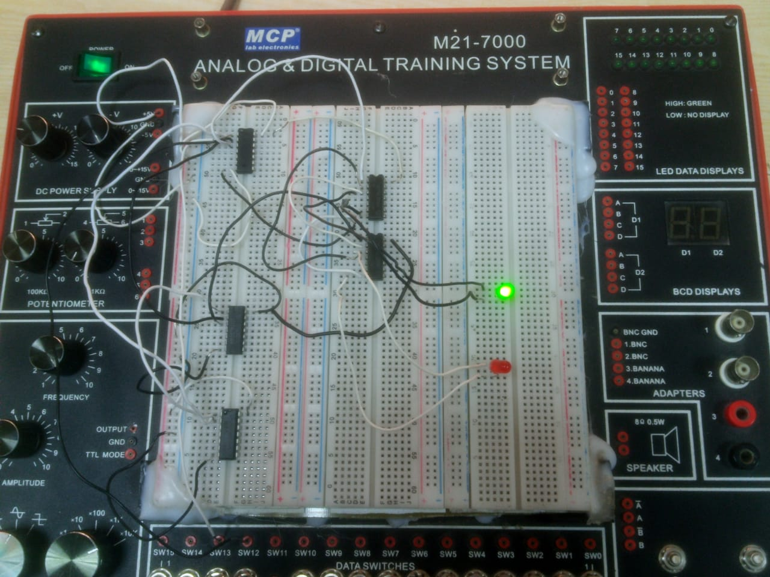
- Image (Proteus):

Image 1:

- When D=0, E=1 then Q=0and Q’=1
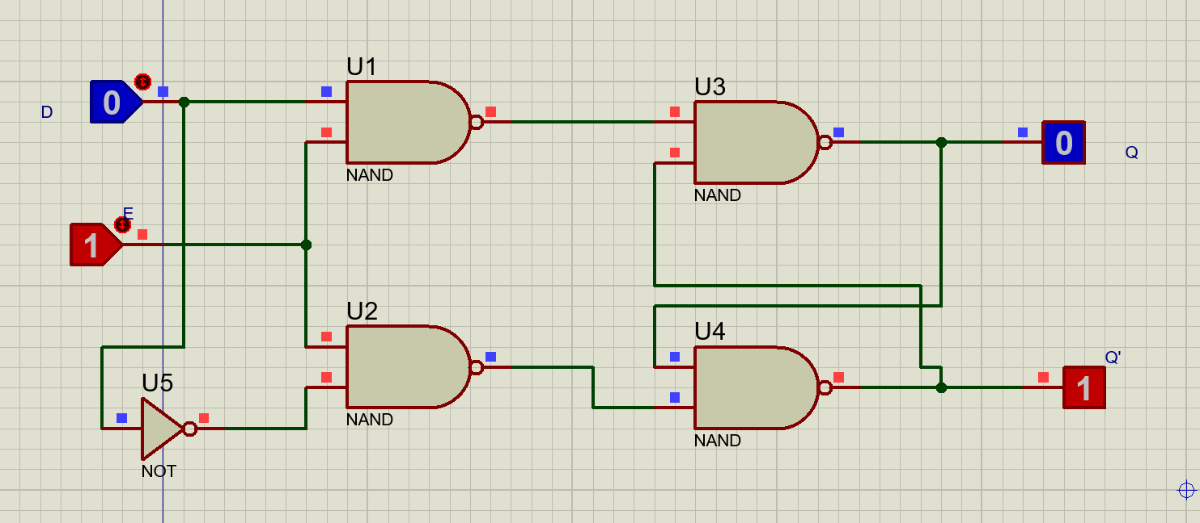
Image 2:
When D=1, E=1 then Q=1 and Q’=0
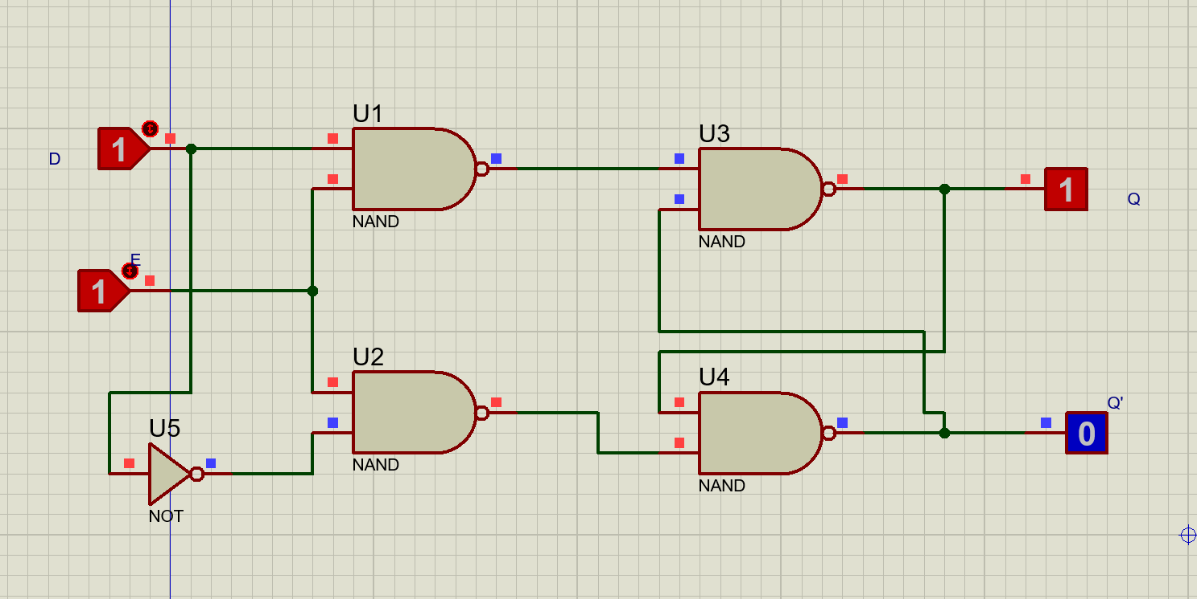
Image 3:
- When D=0, E=0 then Q=1 and Q’=0
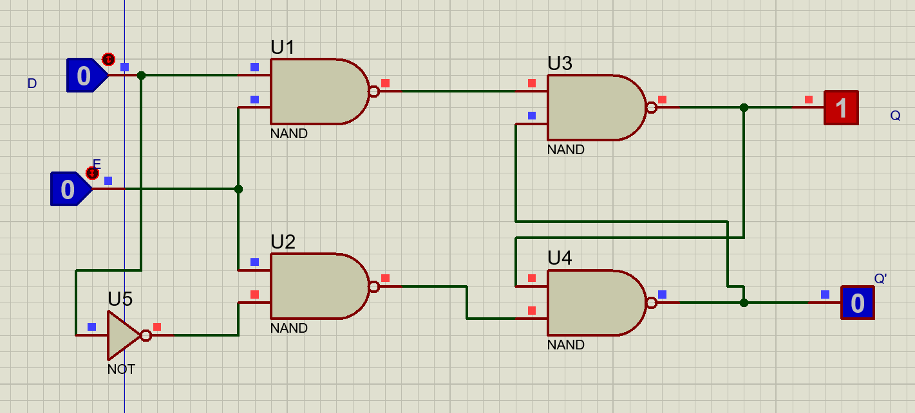
Conclusion:
In this lab, we successfully implemented and tested various types of latches using NAND and NOR gates. By following the procedures and safety measures, we ensured accurate and reliable results. This lab has enhanced our understanding of digital circuits and their practical applications.

